|  |  |
| --- | --- |
|  | **Mitocease App Instalation Instructions** |

The following instructions are intented to be a guide on the Installation of the Mitocease Application on an Android Device.

The instructions are based on a Lenovo Tab M10 FHD Plus running Android 10 version.

For any questions please refer to [roberto.herreramatamoros@bsci.com](mailto:roberto.herreramatamoros@bsci.com).

# **1. Pre-requisites**

## **1A. Enable Developer mode**

* Navigate to the **Settings** Menu, and scroll all the way to the bottom to the **System** Menu.

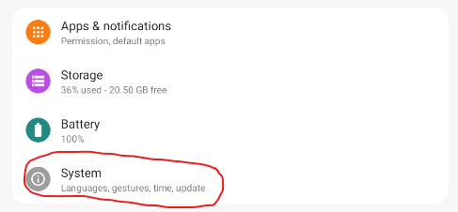

**NOTE:** The Settings menu can be accessed by swiping down from the top of the Screen.

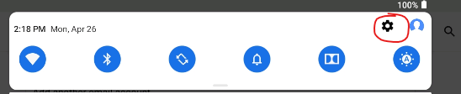

* Select the **About Tablet** option from the menu.

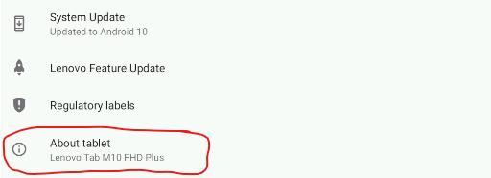

* Tap 7 times in the **Build Number** option, until the device warns you that you have enabled the **Developer Mode**.

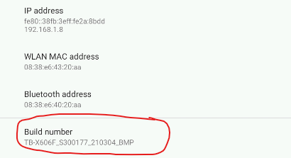

## **1B. Allow Third Party Apps**

* From the **Settings** Menu, select the **Apps & Notifications** option.

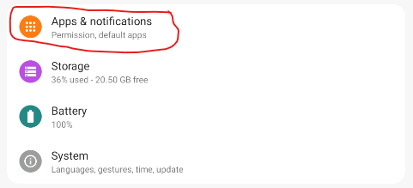

* Select the **Special app access** option on the bottom.

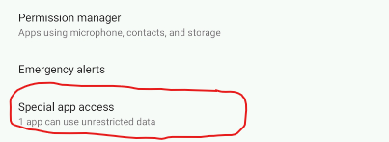

* Select the “**Install unknown apps**” option.

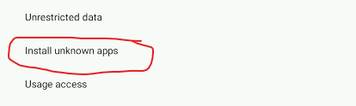

* Select the following sources and for each one toggle the switch to enable the “**Allow from this source**” option.

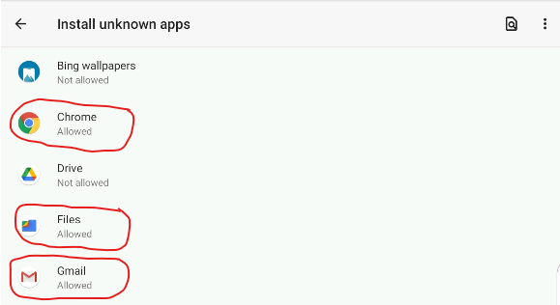

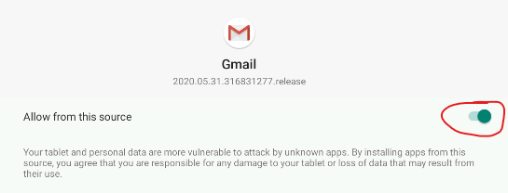

## **1C. Enable WLAN and Bluetooth Scanning**

* Navigate to the **Settings** Menu, and select the **Location** Menu.

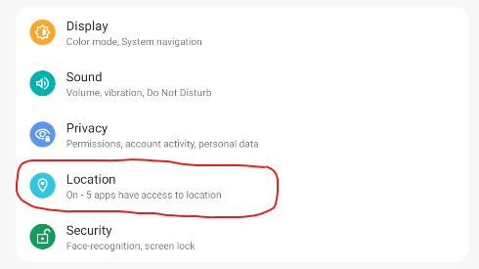

* **Select the WLAN and Bluetooth scanning** option.

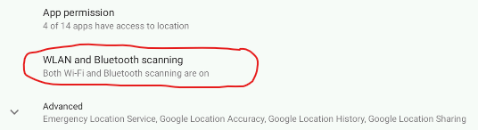

* Enable both options on the menu.

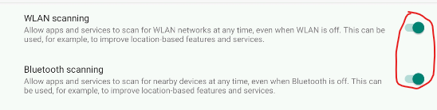

## **1D. Enable USB connection to computer**

* Navigate to the **Settings** Menu, and choose the **Connected Devices** option.

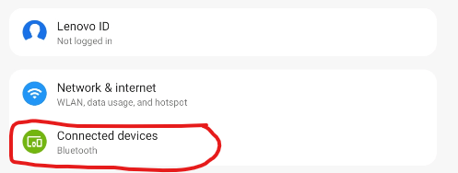

* Click on the **USB** option

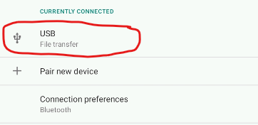

* Ensure the Media Device (MTP) option is selected.

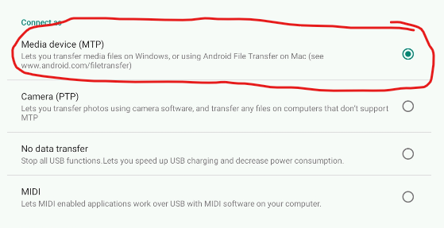

# **2. Application Instalation**

## **2A. Copy application file (.apk) to your device.**

* You will be provided an .apk extension file that contains the compiled release application.
* Example “mitocease_release_v0.1.apk”
* The file could be provided as an attachment to an email, Microsoft Teams file, etc.
* Plug your Tablet to your Windows laptop via the USB-C cable.
* If you followed the instructions on section 1D, then you will get the following icon on your computer.

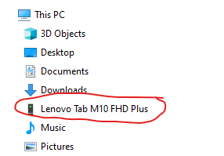

* Navigate into Internal Shared Storage > Download and copy your .apk file there.
  1. *NOTE: Any other location is also valid, but this one is suggested as it is easy to follow there.*

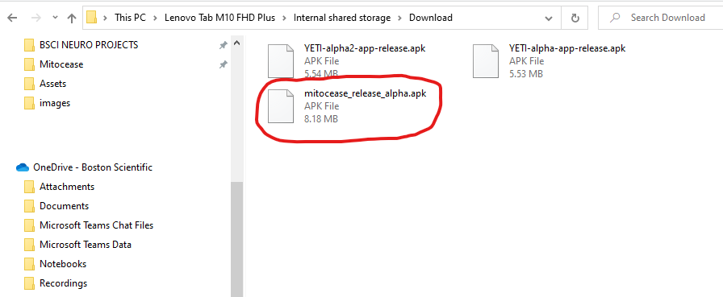

## **2B. Install the application.**

* In your Tablet, open the Applications menu (swipe from the bottom up), and open the Files Application (comes installed with your system).

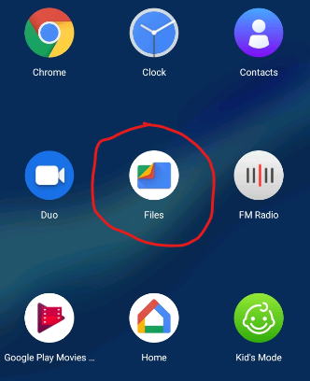

* Navigate to the Downloads options (that’s why that location was suggested before).

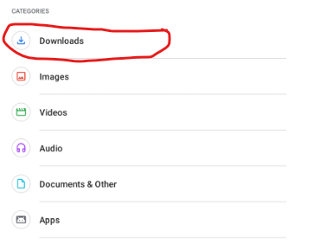

* Locate the mitocease application (ensure that the right version is selected), and click on the “bottom” arrow icon at the far right, and click on “Install”. On the confirmation screen, select “Install” as well. The “App Installed” window should appear.

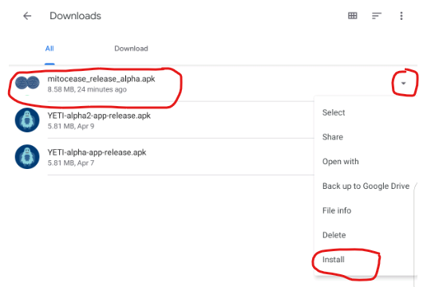

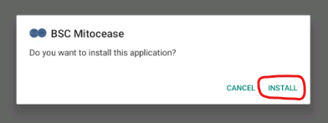

## **2C. Enable permissions.**

* You should be able to see the BSC Mitocease app icon on your home screen.
* Click on the icon to open the application.

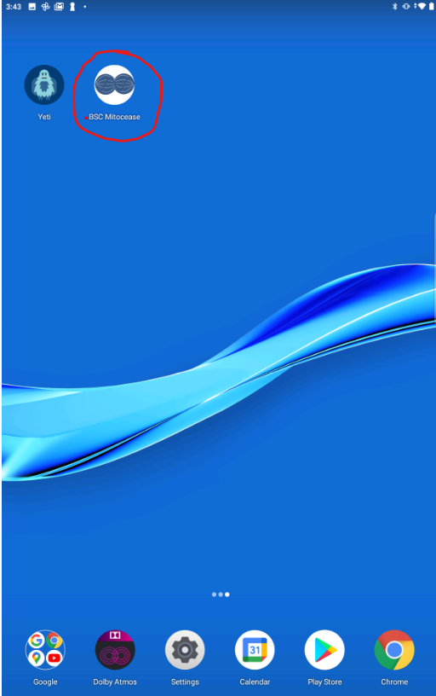

* The first time(s) you use the app on your device, it might ask you to enable the following permissions. Click on the first option to allow it.

